5. Modelo de classes
Package in package 'Inclua nome do projeto'

5. Modelo de classes
Version 1.0 Phase 1.0 Proposed
Fabiane created on 28/02/2019. Last modified 28/02/2019

5. Modelo de classes diagram
Class diagram in package '5. Modelo de classes'

5. Modelo de classes
Version 1.0
Fabiane created on 28/02/2019. Last modified 17/05/2026

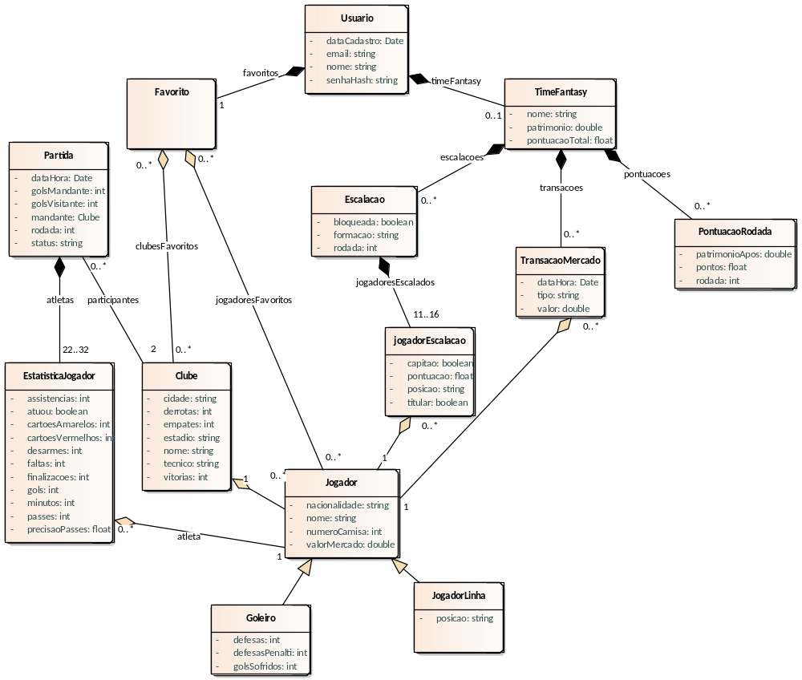

- 5. Modelo de classes

Clube
Class in package '5. Modelo de classes'

Clube
Version 1.0 Phase 1.0 Proposed
Usuario created on 21/04/2026. Last modified 21/04/2026

OUTGOING STRUCTURAL RELATIONSHIPS
Aggregation from Clube to Favorito
[ Name is clubesFavoritos. Direction is 'Source -> Destination'. ]

INCOMING STRUCTURAL RELATIONSHIPS
Aggregation from Jogador to Clube
[ Direction is 'Source -> Destination'. ]

ATTRIBUTES
cidade : string Private
[ Is static True. Containment is Not Specified. ]

derrotas : int Private
[ Is static True. Containment is Not Specified. ]

empates : int Private
[ Is static True. Containment is Not Specified. ]

estadio : string Private
[ Is static True. Containment is Not Specified. ]

nome : string Private
[ Is static True. Containment is Not Specified. ]

tecnico : string Private
[ Is static True. Containment is Not Specified. ]

vitorias : int Private
[ Is static True. Containment is Not Specified. ]

ASSOCIATIONS
Association (direction: Unspecified) participantes

Source: Public (Class) Partida  Cardinality: [0..*] | Target: Public (Class) Clube  Cardinality: [2]

Escalacao
Class in package '5. Modelo de classes'

Escalacao
Version 1.0 Phase 1.0 Proposed
Usuario created on 21/04/2026. Last modified 21/04/2026

OUTGOING STRUCTURAL RELATIONSHIPS
Aggregation from Escalacao to TimeFantasy
[ Name is escalacoes. Direction is 'Source -> Destination'. ]

INCOMING STRUCTURAL RELATIONSHIPS
Aggregation from jogadorEscalacao to Escalacao
[ Name is jogadoresEscalados. Direction is 'Source -> Destination'. ]

ATTRIBUTES
bloqueada : boolean Private
[ Is static True. Containment is Not Specified. ]

formacao : string Private
[ Is static True. Containment is Not Specified. ]

rodada : int Private
[ Is static True. Containment is Not Specified. ]

EstatisticaJogador
Class in package '5. Modelo de classes'

EstatisticaJogador
Version 1.0 Phase 1.0 Proposed
Usuario created on 21/04/2026. Last modified 21/04/2026

OUTGOING STRUCTURAL RELATIONSHIPS
Aggregation from EstatisticaJogador to Partida
[ Name is atletas. Direction is 'Source -> Destination'. ]

INCOMING STRUCTURAL RELATIONSHIPS
Aggregation from Jogador to EstatisticaJogador
[ Name is atleta. Direction is 'Source -> Destination'. ]

ATTRIBUTES
assistencias : int Private
[ Is static True. Containment is Not Specified. ]

atuou : boolean Private
[ Is static True. Containment is Not Specified. ]

cartoesAmarelos : int Private
[ Is static True. Containment is Not Specified. ]

cartoesVermelhos : int Private
[ Is static True. Containment is Not Specified. ]

desarmes : int Private
[ Is static True. Containment is Not Specified. ]

faltas : int Private
[ Is static True. Containment is Not Specified. ]

finalizacoes : int Private
[ Is static True. Containment is Not Specified. ]

gols : int Private
[ Is static True. Containment is Not Specified. ]

minutos : int Private
[ Is static True. Containment is Not Specified. ]

passes : int Private
[ Is static True. Containment is Not Specified. ]

precisaoPasses : float Private
[ Is static True. Containment is Not Specified. ]

Favorito
Class in package '5. Modelo de classes'

Favorito
Version 1.0 Phase 1.0 Proposed
Usuario created on 21/04/2026. Last modified 21/04/2026

OUTGOING STRUCTURAL RELATIONSHIPS
Aggregation from Favorito to Usuario
[ Name is favoritos. Direction is 'Source -> Destination'. ]

INCOMING STRUCTURAL RELATIONSHIPS
Aggregation from Clube to Favorito
[ Name is clubesFavoritos. Direction is 'Source -> Destination'. ]

Aggregation from Jogador to Favorito
[ Name is jogadoresFavoritos. Direction is 'Source -> Destination'. ]

Goleiro
Class in package '5. Modelo de classes'

Goleiro
Version 1.0 Phase 1.0 Proposed
Usuario created on 21/04/2026. Last modified 21/04/2026
Extends Jogador

OUTGOING STRUCTURAL RELATIONSHIPS
Generalization from Goleiro to Jogador
[ Direction is 'Source -> Destination'. ]

ATTRIBUTES
defesas : int Private
[ Is static True. Containment is Not Specified. ]

defesasPenalti : int Private
[ Is static True. Containment is Not Specified. ]

golsSofridos : int Private
[ Is static True. Containment is Not Specified. ]

Jogador
Class in package '5. Modelo de classes'

Jogador
Version 1.0 Phase 1.0 Proposed
Usuario created on 21/04/2026. Last modified 21/04/2026

OUTGOING STRUCTURAL RELATIONSHIPS
Aggregation from Jogador to jogadorEscalacao
[ Direction is 'Source -> Destination'. ]

Aggregation from Jogador to TransacaoMercado
[ Direction is 'Source -> Destination'. ]

Aggregation from Jogador to EstatisticaJogador
[ Name is atleta. Direction is 'Source -> Destination'. ]

Aggregation from Jogador to Clube
[ Direction is 'Source -> Destination'. ]

Aggregation from Jogador to Favorito
[ Name is jogadoresFavoritos. Direction is 'Source -> Destination'. ]

INCOMING STRUCTURAL RELATIONSHIPS
Generalization from JogadorLinha to Jogador
[ Direction is 'Source -> Destination'. ]

Generalization from Goleiro to Jogador
[ Direction is 'Source -> Destination'. ]

ATTRIBUTES
nacionalidade : string Private
[ Is static True. Containment is Not Specified. ]

nome : string Private
[ Is static True. Containment is Not Specified. ]

numeroCamisa : int Private
[ Is static True. Containment is Not Specified. ]

valorMercado : double Private
[ Is static True. Containment is Not Specified. ]

jogadorEscalacao
Class in package '5. Modelo de classes'

jogadorEscalacao
Version 1.0 Phase 1.0 Proposed
Usuario created on 21/04/2026. Last modified 21/04/2026

OUTGOING STRUCTURAL RELATIONSHIPS
Aggregation from jogadorEscalacao to Escalacao
[ Name is jogadoresEscalados. Direction is 'Source -> Destination'. ]

INCOMING STRUCTURAL RELATIONSHIPS
Aggregation from Jogador to jogadorEscalacao
[ Direction is 'Source -> Destination'. ]

ATTRIBUTES
capitao : boolean Private
[ Is static True. Containment is Not Specified. ]

pontuacao : float Private
[ Is static True. Containment is Not Specified. ]

posicao : string Private
[ Is static True. Containment is Not Specified. ]

titular : boolean Private
[ Is static True. Containment is Not Specified. ]

JogadorLinha
Class in package '5. Modelo de classes'

JogadorLinha
Version 1.0 Phase 1.0 Proposed
Usuario created on 21/04/2026. Last modified 21/04/2026
Extends Jogador

OUTGOING STRUCTURAL RELATIONSHIPS
Generalization from JogadorLinha to Jogador
[ Direction is 'Source -> Destination'. ]

ATTRIBUTES
posicao : string Private
[ Is static True. Containment is Not Specified. ]

Partida
Class in package '5. Modelo de classes'

Partida
Version 1.0 Phase 1.0 Proposed
Usuario created on 21/04/2026. Last modified 21/04/2026

INCOMING STRUCTURAL RELATIONSHIPS
Aggregation from EstatisticaJogador to Partida
[ Name is atletas. Direction is 'Source -> Destination'. ]

ATTRIBUTES
dataHora : Date Private
[ Is static True. Containment is Not Specified. ]

golsMandante : int Private
[ Is static True. Containment is Not Specified. ]

golsVisitante : int Private
[ Is static True. Containment is Not Specified. ]

mandante : Clube Private
[ Is static True. Containment is Not Specified. ]

rodada : int Private
[ Is static True. Containment is Not Specified. ]

status : string Private
[ Is static True. Containment is Not Specified. ]

ASSOCIATIONS
Association (direction: Unspecified) participantes

Source: Public (Class) Partida  Cardinality: [0..*] | Target: Public (Class) Clube  Cardinality: [2]

PontuacaoRodada
Class in package '5. Modelo de classes'

PontuacaoRodada
Version 1.0 Phase 1.0 Proposed
Usuario created on 21/04/2026. Last modified 21/04/2026

OUTGOING STRUCTURAL RELATIONSHIPS
Aggregation from PontuacaoRodada to TimeFantasy
[ Name is pontuacoes. Direction is 'Source -> Destination'. ]

ATTRIBUTES
patrimonioApos : double Private
[ Is static True. Containment is Not Specified. ]

pontos : float Private
[ Is static True. Containment is Not Specified. ]

rodada : int Private
[ Is static True. Containment is Not Specified. ]

TimeFantasy
Class in package '5. Modelo de classes'

TimeFantasy
Version 1.0 Phase 1.0 Proposed
Usuario created on 21/04/2026. Last modified 21/04/2026

OUTGOING STRUCTURAL RELATIONSHIPS
Aggregation from TimeFantasy to Usuario
[ Name is timeFantasy. Direction is 'Source -> Destination'. ]

INCOMING STRUCTURAL RELATIONSHIPS
Aggregation from Escalacao to TimeFantasy
[ Name is escalacoes. Direction is 'Source -> Destination'. ]

Aggregation from TransacaoMercado to TimeFantasy
[ Name is transacoes. Direction is 'Source -> Destination'. ]

Aggregation from PontuacaoRodada to TimeFantasy
[ Name is pontuacoes. Direction is 'Source -> Destination'. ]

ATTRIBUTES
nome : string Private
[ Is static True. Containment is Not Specified. ]

patrimonio : double Private
[ Is static True. Containment is Not Specified. ]

pontuacaoTotal : float Private
[ Is static True. Containment is Not Specified. ]

TransacaoMercado
Class in package '5. Modelo de classes'

TransacaoMercado
Version 1.0 Phase 1.0 Proposed
Usuario created on 21/04/2026. Last modified 21/04/2026

OUTGOING STRUCTURAL RELATIONSHIPS
Aggregation from TransacaoMercado to TimeFantasy
[ Name is transacoes. Direction is 'Source -> Destination'. ]

INCOMING STRUCTURAL RELATIONSHIPS
Aggregation from Jogador to TransacaoMercado
[ Direction is 'Source -> Destination'. ]

ATTRIBUTES
dataHora : Date Private
[ Is static True. Containment is Not Specified. ]

tipo : string Private
[ Is static True. Containment is Not Specified. ]

valor : double Private
[ Is static True. Containment is Not Specified. ]

Usuario
Class in package '5. Modelo de classes'

Usuario
Version 1.0 Phase 1.0 Proposed
Usuario created on 21/04/2026. Last modified 21/04/2026

INCOMING STRUCTURAL RELATIONSHIPS
Aggregation from TimeFantasy to Usuario
[ Name is timeFantasy. Direction is 'Source -> Destination'. ]

Aggregation from Favorito to Usuario
[ Name is favoritos. Direction is 'Source -> Destination'. ]

ATTRIBUTES
dataCadastro : Date Private
[ Is static True. Containment is Not Specified. ]

email : string Private
[ Is static True. Containment is Not Specified. ]

nome : string Private
[ Is static True. Containment is Not Specified. ]

senhaHash : string Private
[ Is static True. Containment is Not Specified. ]

